Book Review Links

093
Silent Film Performers by Roy Liebman
CLICK on Book Cover for AMAZON Book Review 093 by Stephen Michael Shearer – February 7, 2022
A MUST HAVE FILM BOOK (amazon.com)
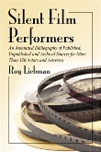

092
The Rain May Pass by Alan Shayne
CLICK on Book Cover for AMAZON Book Review 092 by Stephen Michael Shearer – February 7, 2022
A PERSONAL MEMOIR OF COMING OF AGE (amazon.com)
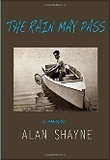

091
Chaplin at Essanay: A Film Artist in Transition, 1915-1916 by James L. Neibaur
CLICK on Book Cover for AMAZON Book Review 091 by Stephen Michael Shearer – February 6, 2022
CHAPLIN AT ESSANAY AT LAST (amazon.com)
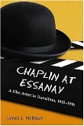

090
The Ile de France and the Golden Age of Transatlantic Travel: High Style on the High Seas by Thomas Kepler
CLICK on Book Cover for AMAZON Book Review 090 by Stephen Michael Shearer – February 6, 2022
A GREAT OCEAN LINER GIVEN HER DUE (amazon.com)
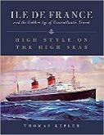

089
Cary Grant, the Making of a Hollywood Legend (CULTURAL BIOGRAPHIES SERIES) by Mark Glancy
CLICK on Book Cover for AMAZON Book Review 089 by Stephen Michael Shearer – February 6, 2022
ACCURATE ACCOUNTING OF THE LIFE OF A SCREEN ICON (amazon.com)
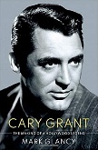

088
Charles Walters: The Director Who Made Hollywood Dance (Screen Classics) by Brent Phillips
CLICK on Book Cover for AMAZON Book Review 088 by Stephen Michael Shearer – February 5, 2022
THE MAGNIFICENT CHARLES WALTERS (amazon.com)
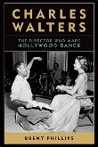
087
Letter from Hollywood: Inside the Private World of Classic American Moviemaking by Rocky Lang & Barbara Hall
CLICK on Book Cover for AMAZON Book Review 087 by Stephen Michael Shearer – February 5, 2022
A MUST HAVE HOLLYWOOD BOOK (amazon.com)
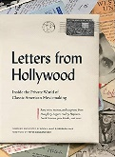

086
Which One Was David by David Frankham
CLICK on Book Cover for AMAZON Book Review 086 by Stephen Michael Shearer – February 5, 2022
A WONDERFUL LIFE (amazon.com)
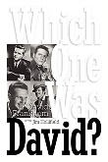

085
Music by Max Steiner: The Epic Life of Hollywood’s Most Influential Composer (Cultural Biographies) by Steven C. Smith
CLICK on Book Cover for AMAZON Book Review 085 by Stephen Michael Shearer – December 14, 2021
LONG AWAITED DEFINITIVE BIOGRAPHY OF A FILM GIANT (amazon.com)

084
My West Side Story: A Memoir by George Chakiris
CLICK on Book Cover for AMAZON Book Review 084 by Stephen Michael Shearer – December 13,2021
BELOVED ACTOR GIVES US HIS MEMOIR (amazon.com)

083
Elizabeth and Monty: The Untold Story of Their Intimate Friendship by Charles Casillo
CLICK on Book Cover for AMAZON Book Review 083 by Stephen Michael Shearer – December 13, 2021
A LEGENDARY FILM COUPLE (amazon.com)
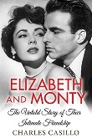

082
Directed by William Beaudine: An Overview by James L. Neibaur
CLICK on Book Cover for AMAZON Book Review 082 by Stephen Michael Shearer – December 3, 2021
ABOUT WILLIAM BEAUDINE (amazon.com)
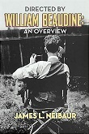

081
100 Years of Brodies with Hal Roach: The Jaunty Journeys of a Hollywood Motion Picture and Television Pioneer by Craig Calman
CLICK on Book Cover for AMAZON Book Review 081 by Stephen Michael Shearer – December 3, 2021
ANOTHER LOOK AT HAL ROACH (amazon.com)
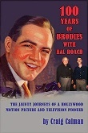

080
MGM British Studios: Hollywood in Borehamwood:
Celebrating 100 Years of the Film Studios of Elstree/Borehamwood, 1914-2014 by Derek Pykett
CLICK on Book Cover for AMAZON Book Review 080 by Stephen Michael Shearer – December 3,2021
AN IMPORTANT HISTORY OF MGM'S BRITISH FILM OUTPUT (amazon.com)
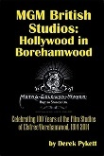

079
S. Sylvan Simon, Moviemaker: Adventures with Lucy, Red Skelton and Harry Cohn in the Golden Age of Hollywood by David C. Tucker
CLICK on Book Cover for AMAZON Book Review 079 by Stephen Michael Shearer – November 26, 2021
A FORGOTTEN HOLLYWOOD GOLDEN AGE DIRECTOR (amazon.com)
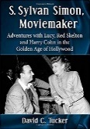

078
Lost Cleopatra: A Tale of Ancient Hollywood by Phillip Dye
CLICK on Book Cover for AMAZON Book Review 078 by Stephen Michael Shearer – November 26, 2021
BRILLIANT BOOK ON A LOST FILM (amazon.com)
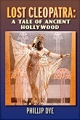

077
Anita Page: A Career Chronicle and Biography by Allan R. Ellenberger & Robert Murdoch Paton
CLICK on Book Cover for AMAZON Book Review 077 by Stephen Michael Shearer – November 26, 2021
Anita Page: A Career Chronicle and Biography: Ellenberger, Allan R., Paton, Robert Murdoch: 9781476676456: Amazon.com: Books

076
Una Merkel: The Actress with Sassy Wit and Southern Charm by Larry Sean Kinder
CLICK on Book Cover for AMAZON Book Review 076 by Stephen Michael Shearer – November 26, 2021
ADORABLE AND VERSATILE UNA MERKEL (amazon.com)
075
Carol Linley: Her Film & TV Career in Thrillers, Fantasy and Suspense by Tom Lisanti
CLICK on Book Cover for AMAZON Book Review 075 by Stephen Michael Shearer – November 26, 2021
A LOVING TRIBUTE TO A LOVELY ACTRESS (amazon.com)
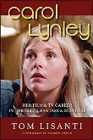

074
Ross Alexander: The Life and Death of a Contract Player by John Franceschina
CLICK on Book Cover for AMAZON Book Review 074 by Stephen Michael Shearer – August 23, 2021
GREAT BOOK ON A TRAGIC FILM PLAYER (amazon.com)
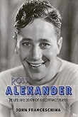

073
Encyclopedia of American Short Films, 1926-1959 by Graham Webb
CLICK on Book Cover for AMAZON Book Review 073 by Stephen Michael Shearer – August 23, 2021
A BRILLIANT FILM SHORT COMPILATION (amazon.com)

072
Little Elf: A Celebration of Harry Langdon by Chuck Harter and Michael J. Hayde
CLICK on Book Cover for AMAZON Book Review 072 by Stephen Michael Shearer – August 23, 2021
LONG OVERDUE TRIBUTE TO HARRY LANGDON (amazon.com)
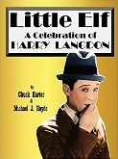

071
Deanna Durbin: A Hollywood Fairy Tale: The Legend of Edna Mae by William Harper
CLICK on Book Cover for AMAZON Book Review 071 by Stephen Michael Shearer – August 12, 2021
A PRIMER FOR DEANNA DURBIN (amazon.com)
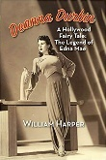

070
CHASE! A Tribute to the Keystone Cop by Lon Davis
CLICK on Book Cover for AMAZON Book Review 070 by Stephen Michael Shearer – August 12, 2021
SILENT FILM COMEDY AT ITS BEST (amazon.com)
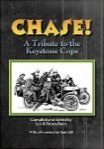

069
Grand National, Producers Releasing Corporation, and Screen Guild/Lippert: Complete Filmographies with Studio Histories by Ted Okuda
CLICK on Book Cover for AMAZON Book Review 069 by Stephen Michael Shearer – December 17, 2020
GREAT SOURCE OF FILM HISTORY (amazon.com)
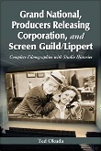

068
Ray Danton: The Epitome of Cool (a career retrospective) by Joseph Fusco
CLICK on Book Cover for AMAZON Book Review 068 by Stephen Michael Shearer – December 17, 2020
A THOROUGH BOOK BUT WE STILL DON"T KNOW RAY DANTON (amazon.com)
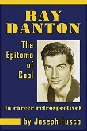

067
Frank Lloyd: Master of Screen Melodrama by Anthony Slide
CLICK on Book Cover for AMAZON Book Review 067 by Stephen Michael Shearer – December 17, 2020
FORGOTTEN FILM DIRECTOR GIVEN HIS DUE (amazon.com)
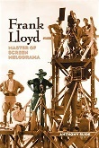

066
Elissa Landi: Cinema’s Empress of Emotion by Scott O’Brien
CLICK on Book Cover for AMAZON Book Review 066 by Stephen Michael Shearer – December 16, 2020
AN IMPORTANT WORK ON A BRILLIANT ACTRESS (amazon.com)
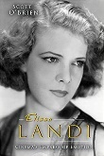

065
Adamant: The Life and Pursuits of Dorothy McGuire by Giancarlo Stampalia
CLICK on Book Cover for AMAZON Book Review 065 by Stephen Michael Shearer – December 16, 2020
A LONG PONDEROUS BIOGRAPHY (amazon.com)
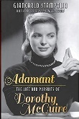

064
Beryl Halley: The Life and Follies of a Ziegfeld Beauty, 1897-1988 by Jacob L. Bapst and Ivan M. Tribe
CLICK on Book Cover for AMAZON Book Review 064 by Stephen Michael Shearer – December 16, 2020
A LOVELY TRIBUTE TO AN ERA GONE BY (amazon.com)
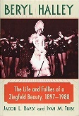

063
The Fox Film Corporation, 1915-1935: A History and Filmography by Aubrey Solomon
CLICK on Book Cover for AMAZON Book Review 063 by Stephen Michael Shearer – December 15, 2020
BRILLIANT BOOK ON EARLY FOX FILMS (amazon.com)
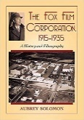

062
Ray Milland: The Films, 1929-1984 by James McKay
CLICK on Book Cover for AMAZON Book Review 062 by Stephen Michael Shearer – June 22, 2020
A WELL DESERVED CAREER STUDY OF RAY MILLAND (amazon.com)
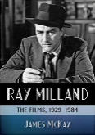

061
The Jean Harlow Films by James L. Neibaur
CLICK on Book Cover for AMAZON Book Review 061 by Stephen Michael Shearer – June 22, 2020
HARLOW FILMS EXAMINED (amazon.com)

060
Hollywood’s Hard-Luck Ladies: 23 Actresses Who Suffered Early Deaths, Accidents, Missteps, Illnesses and Tragedies by Laura Wagner
CLICK on Book Cover for AMAZON Book Review 060 by Stephen Michael Shearer – June 22, 2020
WAGNER'S WONDERFUL WOMEN (amazon.com)

059
Margaret Sullavan: The Life and Career of a Reluctant Star by Michael D. Rinella
CLICK on Book Cover for AMAZON Book Review 059 by Stephen Michael Shearer – June 5, 2020
A VERY GOOD CAREER STUDY (amazon.com)
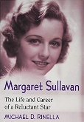

058
Robert Taylor: A Biography by Charles Tranberg
CLICK on Book Cover for AMAZON Book Review 058 by Stephen Michael Shearer – May 26, 2020
AUTHOR TRANBERG STRIKES ANOTHER HIT (amazon.com)
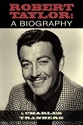

057
Willima Powell: The Life and Films by Roger Bryant
CLICK on Book Cover for AMAZON Book Review 057 by Stephen Michael Shearer – May 26, 2020
GOOD BIO OF A CHARMING ACTOR (amazon.com)
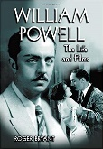

056
The Lost World of DeMille (Hollywood Legends Series) by John Kobal
CLICK on Book Cover for AMAZON Book Review 056 by Stephen Michael Shearer – May 26, 2020
The Lost World of DeMille (Hollywood Legends Series): Kobal, John, Dance, Robert: 9781496825230: Amazon.com: Books
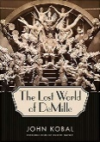

055
Fredric March – A Consummate Actor by Charles Tranberg
CLICK on Book Cover for AMAZON Book Review 055 by Stephen Michael Shearer – May 22, 2020
AN ACTING LEGEND (amazon.com)
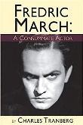

054
Millennium Biltmore: A Grand Hotel Born of Hollywood Dreams by Ward Moorehouse III
CLICK on Book Cover for AMAZON Book Review 054 by Stephen Michael Shearer – April 29, 2020
FASCINATING MILLENNIUM BILTMORE (amazon.com)
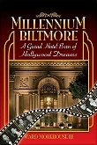

053
Angie: The Life and Films of Angie Dickenson by James Stratton
CLICK on Book Cover for AMAZON Book Review 053 by Stephen Michael Shearer – April 29, 2020
ANGIE AT LAST (amazon.com)

052
Brian Donlevy, the Good Bad Guy: A Bio-Filmography by Derek Sculthorpe
CLICK on Book Cover for AMAZON Book Review 052 by Stephen Michael Shearer – April 29, 2020
A LONG DESERVED BIOGRAPHY (amazon.com)
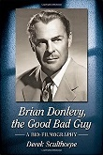

051
Karl Dane: A Biography ad Filmography by Laura Petersen Balogh
CLICK on Book Cover for AMAZON Book Review 051 by Stephen Michael Shearer – April 17, 2020
A TRUE HOLLYWOOD PARABLE (amazon.com)
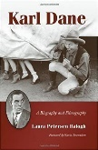

050
Olivia de Havilland: Lady Triumphant (Screen Classics) by Victoria Amador
CLICK on Book Cover for AMAZON Book Review 050 by Stephen Michael Shearer – April 17, 2020
A GREAT STAR...A WEAK BOOK (amazon.com)

049
She Could Be Chaplin!: The Comedic Brilliance of Alice Howell (Hollywood Legends Series) by Anthony Slide
CLICK on Book Cover for AMAZON Book Review 049 by Stephen Michael Shearer – April 17, 2020
A MOST IMPORTANT SILENT FILM STAR (amazon.com)
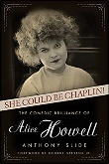

048
MGM Style: Cedric Gibbons and the Art of the Golden Age of Hollywood by Howard Gutner
CLICK on Book Cover for AMAZON Book Review 048 by Stephen Michael Shearer – March 7, 2020
ONE OF THE BEST BOOKS ON HOLLYWOOD (amazon.com)
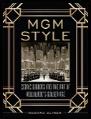

047
The Hollywood Canteen: Where the Greatest Generation Danced With the Most Beautiful Girls in the World by Lisa Mitchell
CLICK on Book Cover for AMAZON Book Review 047 by Stephen Michael Shearer – February 21, 2020
IMPORTANT CULTURAL HISTORY (amazon.com)
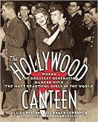

046
Incorrect Entertainment by Anthony Slide
CLICK on Book Cover for AMAZON Book Review 046 by Stephen Michael Shearer – February 21, 2020
FACSINATING IMPROPRIETIES (amazon.com)
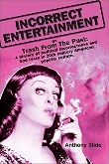

045
Alive on the Andrea Doria!: The Greatest Sea Rescue in History by Pierette Domenica
CLICK on Book Cover for AMAZON Book Review 045 by Stephen Michael Shearer – February 21,2020
CHILLING FIRST HAND ACCOUNTS (amazon.com)

044
Just Joan: A Joan Crawford Appreciation by Donna Marie Nowak
CLICK on Book Cover for AMAZON Book Review 044 by Stephen Michael Shearer – February 17, 2020
MORE ON JOAN CRAWFORD (amazon.com)
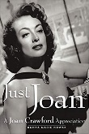

043
Also Starring…: Biographical Essays on the Greatest Character Actors of Hollywood’s Golden Era, 1930-1965 by Sara Brideson
CLICK on Book Cover for AMAZON Book Review 043 by Stephen Michael Shearer – February 17, 2020
FEATURED PLAYERS GIVEN THEIR DUE (amazon.com)
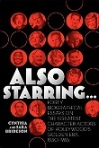

042
Zasu Pitts: The Life and Career by Charles Stumpf
CLICK on Book Cover for AMAZON Book Review 042 by Stephen Michael Shearer – February 2, 2020
ZASU PITTS - A WARM MEMORY (amazon.com)

041
George Raft by Stone Wallace
CLICK on Book Cover for AMAZON Book Review 041 by Stephen Michael Shearer – January 31, 2020
GEORGE RAFT GREAT READ (amazon.com)
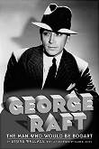

040
Silents of the Vamps: Bad Girls You Don’t Know – But Should by Jennifer Ann Redmond
CLICK on Book Cover for AMAZON Book Review 040 by Stephen Michael Shearer – January 31, 2020
FORGETTABLE VAMPS (amazon.com)

039
Mary Nolan, Ziegfeld Girl and Silent Movie Star: A Biography Including Her 1941 Memoir by Louise Carley Lewisson
CLICK on Book Cover for AMAZON Book Review 039 by Stephen Michael Shearer – January 31, 2020
MUCH MORE NEEDED ON MARY NOLAN (amazon.com)
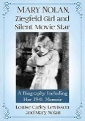

038
Basil Rathbone: His Life and His Films by Michael B. Druxman
CLICK on Book Cover for AMAZON Book Review 038 by Stephen Michael Shearer – January 31, 2020
BRILLIANT BASIL (amazon.com)
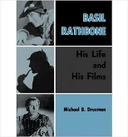

037
Colleen Morre: A Biography of the Silent Film Star by Jeff Codori
CLICK on Book Cover for AMAZON Book Review 037 by Stephen Michael Shearer – January 31, 2020
MORE NEEDED ABOUT MOORE (amazon.com)
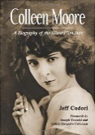

036
They Coulda Been Contenders: Twelve Actors Who Should Have Become Cinematic Superstars by Dan Van Neste
CLICK on Book Cover for AMAZON Book Review 036 by Stephen Michael Shearer – January 17, 2020
A MARVELOUS BIO COMPILATION (amazon.com)
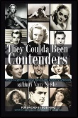

035
Film’s First Family: The Untold Story of the Costellos (Screen Classics) by Terry Chester Shulman
CLICK on Book Cover for AMAZON Book Review 035 by Stephen Michael Shearer – January 17, 2020
FILM'S LEGENDARY FIRST FAMILY (amazon.com)
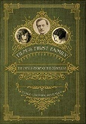

034
Finding Zsa Zsa: The Gabors behind the Legend by Sam Staggs
CLICK on Book Cover for AMAZON Book Review 034 by Stephen Michael Shearer – October 1, 2019
BEFORE THE KARDASHIANS THERE WERE THE GABORS (amazon.com)
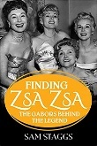

033
The Lives of Justine Johnstone: Follies Star, Research Scientist, Social Activist by Kathleen Vestuto
CLICK on Book Cover for AMAZON Book Review 033 by Stephen Michael Shearer – August 26, 2019
A REMARKABLE STORY OF A FORGOTTEN STAR (amazon.com)
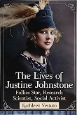

032
Henry Brandon: King of the Bogeymen by Bill Cassara
CLICK on Book Cover for AMAZON Book Review 032 by Stephen Michael Shearer – July 9, 2019
A REMARKABLE CHARACTER ACTOR GIVEN HIS CAREER DUE (amazon.com)
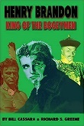

031
Mae West: Broadcast Muse by Michael Gregg Michaud
CLICK on Book Cover for AMAZON Book Review 031 by Stephen Michael Shearer – July 9, 2019
A MOST UNIQUE BOOK ON A MOST UNIQUE SEX GODDESS (amazon.com)
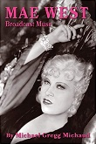

030
Atomic Blonde: The Films of Mamie Van Doren by Barry Lowe
CLICK on Book Cover for AMAZON Book Review 030 by Stephen Michael Shearer – July 8, 2019
LOVING TRIBUTE TO A BLONDE BOMBSHELL (amazon.com)
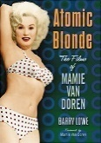

029
Mike Connolly and the Manly Art of Hollywood Gossip by Val Holley
CLICK on Book Cover for AMAZON Book Review 029 by Stephen Michael Shearer – June 25, 2019
A FASCINATING MAN (amazon.com)
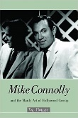

028
Fay Wray and Robert Riskin: A Hollywood Memoir by Victoria Riskin
CLICK on Book Cover for AMAZON Book Review 028 by Stephen Michael Shearer – June 25, 2019
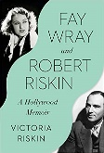

027
Dutch Girl: Audrey Hepburn and World War II by Robert Matzen
CLICK on Book Cover for AMAZON Book Review 027 by Stephen Michael Shearer – April 15, 2019
A MOST IMPORTANT AUDREY HEPBURN BOOK (amazon.com)

026
The Wampas Baby Stars: A Biographical Dictionary, 1922-1934 by Roy Liebman
CLICK on Book Cover for AMAZON Book Review 026 by Stephen Michael Shearer – March 25, 2019
A STARLET TRADITION REMEMBERED (amazon.com)
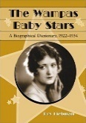

025
Verna Felton by Fredrick Tucker
CLICK on Book Cover for AMAZON Book Review 025 by Stephen Michael Shearer – March 25, 2019
A BELOVED CHARACTER ACTRESS GETS HER DUE (amazon.com)
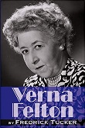

024
The Hal Roach Comedy Shorts of Thelma Todd, Zasu Pitts and Patsy Kelly by James L. Neibaur
CLICK on Book Cover for AMAZON Book Review 024 by Stephen Michael Shearer – March 25, 2019
FOREVER THELMA TODD AND ZASU PITTS.... (amazon.com)
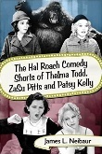

023
Lillian Lorraine: The Life and Times of a Ziegfeld Diva by Nils Hanson
CLICK on Book Cover for AMAZON Book Review 023 by Stephen Michael Shearer – March 25, 2019
A FORGOTTEN STAR GIVEN HER DUE (amazon.com)
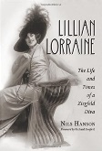

022
About Face: The Life and Times of Dottie Ponedel, Make-up Artist to the Stars by Dorothy Ponedel
CLICK on Book Cover for AMAZON Book Review 022 by Stephen Michael Shearer – March 25, 2019
A DISAPPOINTING BIOGRAPHY (amazon.com)
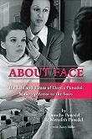

021
Barbara Payton: A Likfe in Pictures by John O’Dowd
CLICK on Book Cover for AMAZON Book Review 021 by Stephen Michael Shearer – January 28, 2019
ONE MAN'S OBSESSION (amazon.com)

020
Grant Williams by Giancarlo Stampalia
CLICK on Book Cover for AMAZON Book Review 020 by Stephen Michael Shearer – August 28, 2018
A CULT STAR REMEMBERED.... (amazon.com)

019
Herbert Marshall: A Biography by Scott O’Brien
CLICK on Book Cover for AMAZON Book Review 019 by Stephen Michael Shearer – August 28, 2018
SCOTT O'BRIEN DELIVERS ANOTHER WIINNING BIOGRAPHY (amazon.com)

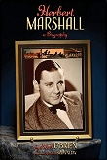

018
The Man Who Made the Movies: The Meteoric Rise and Tragic Fall of William Fox by Vanda Krefft
CLICK on Book Cover for AMAZON Book Review 018 by Stephen Michael Shearer – August 28, 2018
A MAJOR BOOK OF A MAJOR FILM PIONEER (amazon.com)
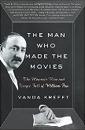

017
Miriam Hopkins: Life and Films of Hollywood Rebel (Screen Classics) by Allan R. Ellenberger
CLICK on Book Cover for AMAZON Book Review 017 by Stephen Michael Shearer – August 28, 2018
REMEMBERING A HOLLYWOOD LEGEND (amazon.com)
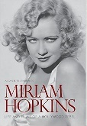

016
Pamela Tiffin: Hollywood to Rome by Tom Lisanti
CLICK on Book Cover for AMAZON Book Review 016 by Stephen Michael Shearer – August 28, 2018
REMEMBERING A STARLET (amazon.com)

015
Frances Langford: Armed Forces Sweetheart by
CLICK on Book Cover for AMAZON Book Review 015 by Stephen Michael Shearer – April 24, 2018
A LOVING VALENTINE TO AN AMERICAN SWEETHEART.... (amazon.com)

014
Manhandled (Blu-ray) An Allan Dwan Production
CLICK on Book Cover for AMAZON Book Review 014 by Stephen Michael Shearer – April 24, 2018
SWANSON'S BEST SILENT FILM COMEDY... (amazon.com)

013
Stage Struck (Blu-ray) An Allan Dwan Production
CLICK on Book Cover for AMAZON Book Review 013 by Stephen Michael Shearer – April 24, 2018
GLORIA IN GLORIOUS BLACK AND WHITE AND TECHNICOLOR..... (amazon.com)
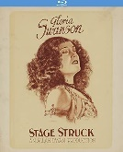

012
The Silent Films of Marion Davies
CLICK on Book Cover for AMAZON Book Review 012 by Stephen Michael Shearer – November 27, 2017
A BRILLIANT AND SINCERE TRIBUTE (amazon.com)

011
Pola Negri: The Hollywood Years by Tony Villecco
CLICK on Book Cover for AMAZON Book Review 011 by Stephen Michael Shearer – September 28, 2017
NEGRI IN HOLLYWOOD (amazon.com)
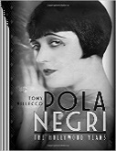

010
The Magnificent Heel: The Life and Films of Ricardo Cortez by Dan Van Neste
CLICK on Book Cover for AMAZON Book Review 010 by Stephen Michael Shearer – July 11, 2017
To many of us the name RICARDO CORTEZ is best remembered in film exactly as the author has pointed ... (amazon.com)
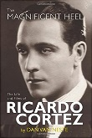

009
Broken Silence: Conversations with 23 Silent Film Stars by Michael G. Ankerich
CLICK on Book Cover for AMAZON Book Review 009 by Stephen Michael Shearer – July 11, 2017
BROKEN SILENCE – CONVERSATIONS WITH 23 SILENT FILM STARS is a wonderfully informative and historical film volume (amazon.com)
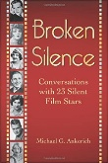

008
Alan Sues: A Funny Man by Michael Michaud
CLICK on Book Cover for AMAZON Book Review 008 by Stephen Michael Shearer – July 11, 2017
A LOVING BIOGRAPHY.... (amazon.com)
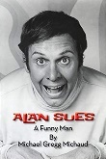

007
The Purple Diaries: Mary Astor and the Most Sensational Hollywood Scandal of the 1930s by Joseph Egan
CLICK on Book Cover for AMAZON Book Review 007 by Stephen Michael Shearer – May 14, 2017
THE STORY OF A SCANDAL (amazon.com)
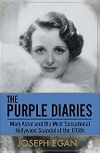

006
The Sound of Silence: Conversations with 16 Film and Stage Personalities…by Michael G. Ankerich
CLICK on Book Cover for AMAZON Book Review 006 by Stephen Michael Shearer – May 14, 2017
ANKERICH SUCCEEDS IN YET ANOTHER CLASSIC (amazon.com)
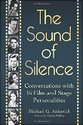

005
Golden Images: 41 Essays on Silent Film Stars by Eve Golden
CLICK on Book Cover for AMAZON Book Review 005 by Stephen Michael Shearer – May 14, 2017
A MUST READ BOOK...... (amazon.com)
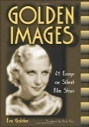

004
Foxy Lady: The Authorized Biography of Lynn Bari by Jeff Gordon
CLICK on Book Cover for AMAZON Book Review 004 by Stephen Michael Shearer – February 27, 2017
the beautiful and very professionally well-liked Bari climbed the ladder to ... (amazon.com)

003
Vitaphone Films: A Catalogue of the Features and Shorts by Roy Liebman
CLICK on Book Cover for AMAZON Book Review 003 by Stephen Michael Shearer – January 30, 2017
A MAJOR AND IMPORTANT BOOK (amazon.com)
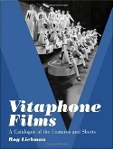

002
SYLVIA SIDNEY – Paid by the Tear by Scott O’Brien
CLICK on Book Cover for AMAZON Book Review 002 by Stephen Michael Shearer – January 9, 2017
ANOTHER BRILLIANT BIOGRAPHY FROM SCOTT O’BRIEN (amazon.com)

001
Affectionately, Jayne Mansfield by Richard Koper
CLICK on Book Cover for AMAZON Book Review 001 by Stephen Michael Shearer – October 24. 2016
JAYNE MANSFIELD....A Dedicated Biography..... (amazon.com)

