Subject: Press Kit - Stephen Michael Shearer
Available for Review: PATRICIA NEAL: AN UNQUIET LIFE, UPDATED AND EXPANDED EDITION

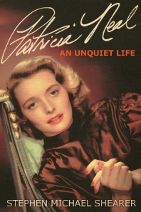  Digital review copy and more information available in the DOWNLOADABLE MEDIA KIT.  For additional information, physical review copies, and interview requests:  Jackie Wilson  jackie.wilson@uky.edu  Patricia Neal: An Unquiet Life, Updated and Expanded Edition  Stephen Michael Shearer  The internationally acclaimed actress Patricia Neal (1926–2010) was a star on stage, film, and television for more than sixty years. On Broadway she appeared in such productions as Lillian Hellman’s Another Part of the Forest, winning the first Tony award, and in The Miracle Worker. In Hollywood she starred opposite the likes of John Wayne, Paul Newman, John Garfield, and Gary Cooper in some thirty films. She is perhaps best known for her portrayal of Alma Brown in Hud, which earned her the 1963 Academy Award for Best Actress.  But there was much more to Neal’s life. For a time, Neal was romantically involved with Gary Cooper, her married costar in The Fountainhead. In 1953, Neal wed famed children’s author Roald Dahl, a match that brought her five children and thirty years of dramatic ups and downs. At the pinnacle of her screen career, Neal suffered a series of strokes that left her in a coma for twenty-one days, and Variety even ran a headline erroneously stating that she had died. After a difficult recovery, Neal returned to film acting, earning a second Academy Award nomination for The Subject Was Roses (1968). She appeared in several television movie roles in the 1970s and 1980s and won a Golden Globe for Best Actress in a Dramatic TV Movie in 1971 for The Homecoming.  This book is the first critical biography detailing the actress’s impressive film career and her remarkable life, which she lived with determination and bravado. | Adapted as a major motion picture starring Hugh Bonneville, Keeley Hawes, and Sam Heughan, TO OLIVIA is out now on Sky Cinema!  Watch the trailer here.  Praise for Patricia Neal: An Unquiet Life  “Patricia Neal has traveled the road from triumph to despair in ways few of us can imagine. There is sincerity and dedication behind this work.”—Paul Newman  “Screen legend Neal’s life was filled with tragedies and triumphs, and Shearer unveils an impressive portrait of the actress.”—Publishers Weekly  About the Author  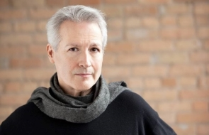  © Craig VanDerSchaegen Photography, Minneapolis  Stephen Michael Shearer, who has worked as a professional actor, is the author of Beautiful: The Life of Hedy Lamarr and Gloria Swanson: The Ultimate Star. He has written for the Las Vegas Review-Journal and The Film Collectors Registry, and he has contributed research to the Academy of Motion Picture Arts and Sciences. He lives in Woodbury, Minnesota.  DOWNLOADABLE MEDIA KIT  Physical review copies available upon request.

