
www.smsmybooks.com

STEPHEN MICHAEL SHEARER - SCHEDULE
FEBRUARY 2025 through DECEMBER 2025 (CONFIRMED/PENDING/IN WORKS Schedule)

January through February 2025 Schedule-CONFIRMED & PENDING
NEW BOOK RELEASE TOUR 2025
Minneapolis, MN (Minneapolis Women’s Club Private Event) – Confirmed Date Pending
Big Sky, MT (Ski Resort) – Confirmed
Chicago, IL (Research) -Confirmed

March through May 2025 Schedule-CONFIRMED & PENDING
NEW BOOK RELEASE TOUR 2025
Chicago, IL (Research) - Confirmed
New York, NY (Book Event) - PENDING
Fredericksburg, VA (Great Lives Lecture Series) Mary Washington University – March 18, 2025 – Confirmed
Washington, DC (Cherry Blossom Festival) – Confirmed
Palm Springs, CA (Just Fabulous) – Paso Robles, CA (Art of the Vineyard Gallery) - PENDING
Los Angeles, CA (Larry Edmond’s Books & Egyptian Theater Event) & (The AMPAS Museum Store) - PENDING

May through December 2025 Schedule-CONFIRMED & PENDING
NEW BOOK RELEASE TOUR 2025
Washington, DC (Library of Congress, National Book Fair)
Las Vegas, NV (Library System Book Event)
Los Angeles, CA (LA Times Book Festival at USC)
Washington, DC (National HRC Event)
Minneapolis, MN (HRC) – San Francisco, CA (HRC)
Boston, MA (Book Festival)
Hawaii Tour (Honolulu, Hilo, Kona, Kaanapali/Lahaina, Lihue)

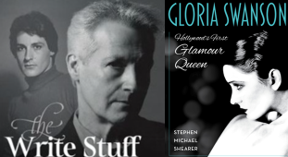
New Book Released – January 7th, 2025

